ECE 3300L

Lab 10: FIFO Controlling RGB

Instructor: Dr. Mohamed El-Hadedy

Group A

Sami Elias, Joseph Popoviciu

**Objective:**

Create a push/pull module using FIFO. Use the values that are pulled to change the color of the RGB LEDs.

**Results:**

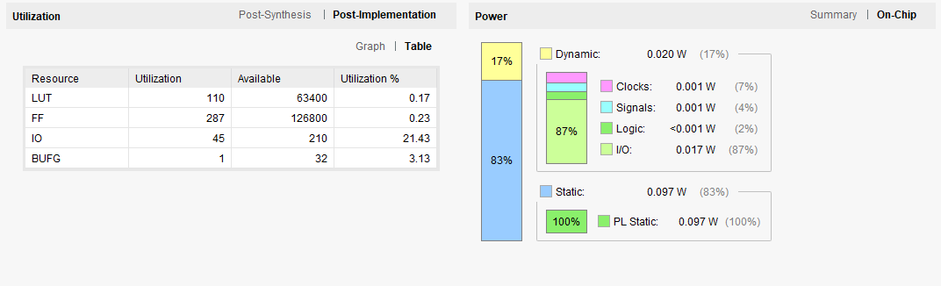

Figure 1: Utilization Table

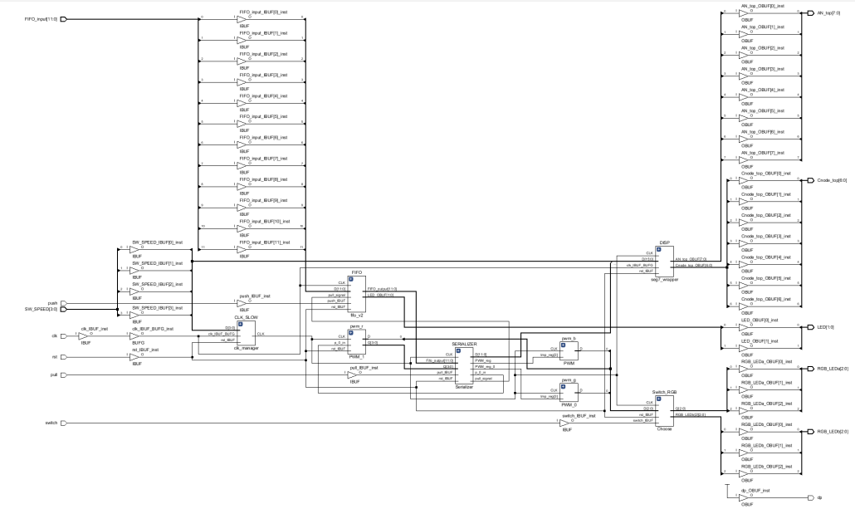

Figure 2: Implementation Schematic

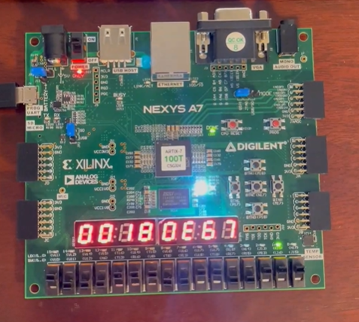

Figure 3: Working Board

We have switches to control the clock manager and the FIFO. The left four switches control the clock manager. This allows us to speed up or slow down the clock. The rest of the switches are for the FIFO inputs. The two LEDs on the right are to signify if the FIFO is full or empty. The left LED is empty and the right LED is full. The button P17 which is the left button, pushes data into the FIFO. M17, the button on the right, pulls from the FIFO. M18, the top button, switches between the RGB LEDs. N17, the middle button, is the reset button. When we load a number into the FIFO, the LED on the right will light up indicating that it is full. When we pull the value, it will load into the RGB LED and change its color to whatever the value is. If we switch the RGB, the process will be the same, but for the other LED.